# FLIGHT BOOKING SYSTEM

Low Level Diagrams



**Presented By:**

NITHYA LAKSHMI VARA PRASANNA YARRAMSETTI

Table of Contents

1.0 Introduction

2.0 Document Purpose

3.0 Intended Audience

4.0 UML Diagrams

* + 1. Use Case Diagram
    2. Sequential Diagram

iii) Activity Diagram

5.0 Database Diagram

# INTRODUCTION

Flight Booking System is a complete online booking platform which automates flight booking process to help book flights online for particular destinations and make travel easy. This online booking system helps end users to search and book flight tickets online from various flights.

# SOFTWARE REQUIREMENTS

For the following project the software requirements are given below

Frontend : Angular  
Backend : ASP.Net Core with WEBAPI

Database: SQL server

Language: C#

# DOCUMENT PURPOSE

The document will provide the whole idea about the system and the case study. This will also provide a detailed description of requirements and system functionalities of flight booking system. There is a brief description about the working of this newly introduced system. This document will allow the complete understanding of the functionality of proposed system for the given case study.

# INTENDED AUDIENCE

This document is intended as a reference for the following roles who are interested in the following Flight Booking System.

|  |  |
| --- | --- |
| **Role** | **Nature of Engagement in Flight Booking System** |
| **END USER** | The user can search flights; destination from – to, date, search for booking history, check-in. |
| **SERVER** | Server handles the database. Modifies, updates the flight time & details |

**UML DIAGRAMS**

# USE CASE DIAGRAM

# SEQUENCE DIAGRAM

# ACTIVITY DIAGRAM

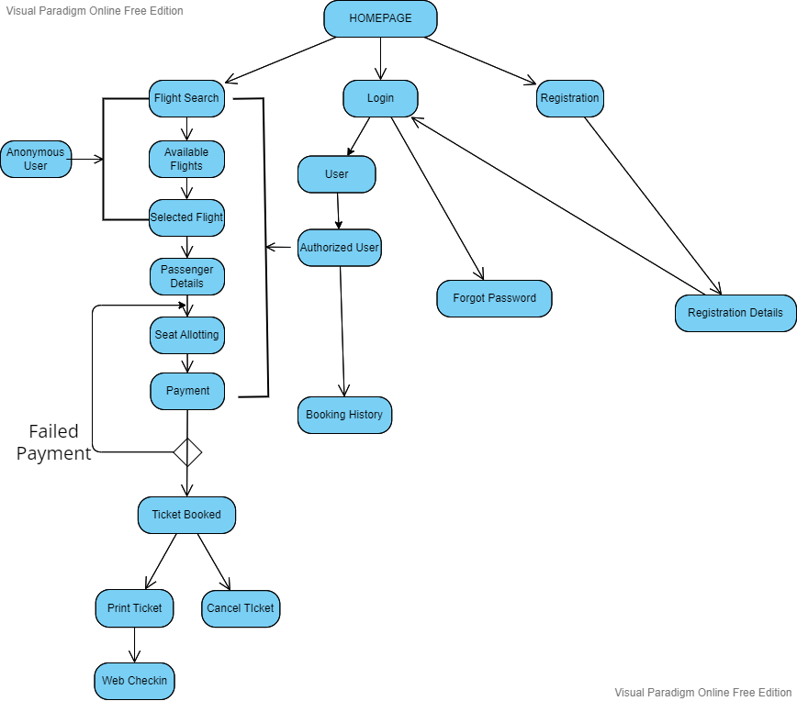

# 

# DATABASE DIAGRAM

# DB.jpg